Chapter 7, Problem 22.

Find i(t) and v(t) for t > 0 in the circuit of Fig. 7.102 if i(0) = 10 A.

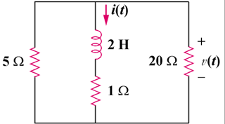

Figure 7.102
For Prob. 7.22.

